**Unit 14 I remember meeting all of you in Grade 7.**

**Section B2 (2a-2e)**

**【学习目标】**

1．掌握重点单词以及短语：gentleman, graduation, ceremony, congratulate，

thirsty, lastly, task，ahead，responsible，wing，attend the graduation ceremony, separate from sb., never fail to be thankful to sb.，set out on your new journey, be responsible for等等。

2．学习句型：

1) First of all, I'd like to congratulate all the students who are here today.

2) I hope you'll remember the important people in your lives who helped and supported you.

3) The key is to learn from mistake学科网(www.zxxk.com)--教育资源门户，提供试卷、教案、课件、论文、素材及各类教学资源下载，还有大量而丰富的教学相关资讯！s and never give up.

**【重点和难点】**

1. 阅读有关校长在毕业典礼上的演讲的文章学科网(www.zxxk.com)--教育资源门户，提供试卷、教案、课件、论文、素材及各类教学资源下载，还有大量而丰富的教学相关资讯！并完成练习，学会分析文章类型和目的。

2. 通过阅读演讲稿，谈论过去，展望未来。

**【课前预习】**

**一、请根据中文意思写出下列重点单词。**

1. 先生；绅士 *n.* _____

2．典礼；仪式 *n.* _____

3．祝贺 *v*. _____

4．渴望的；口渴的 *adj.* _____

5．最后 *adv.* _____

6．任务；工作 *n.* _____

7．向前面；在前面 *adv.* _____

8．有责任心的 *adj.* _____

9．翅膀；翼 *n.* _____

**二、请认真阅读课文，找出下列重点短语。**

10. 出席毕业典礼_____

11. 分离；隔开_____.

12. 充满活力_____

13．渴求知识_____

14．对未来的希望_____

15．一定要向某人表达感激_____.

16．给某人飞翔的翅膀_____

17．开始你的新旅程_____

18．对你的决定和行为负责_____

19．走自己的路_____

**三、请用以上重点短语完成下列句子。**

20．一定要向你周围的人表达感激。

Never fail to _____ _____ _____ _____ _____ _____ _____．

21．明智地选择，对你的决定和行为负责。

Choose wisely and _____ _____ _____ _____ _____ _____ _____．

22．当你新的旅程启程之际，不应忘了你来自何处。

As you_____ _____ _____ _____ _____ _____, you shouldn't forget where you came from.

**【合作探究】**

**探究一、**Read 2b and get the main idea of the passage.

1．Fast reading. (快速阅读)

Read the passage quickly and answer the questions.

① What kind of text is this? Is it a story，a speech or a notice?

② Who do you think wrote it?

③ Who is it for?

2. Intensive reading. (精读)

Read the article carefully, then finish the tasks in 2c和2d.

3. I can retell. (我会复述)

你能写下文章的要点，并根据它们进行复述吗？大胆挑战一下自我吧！

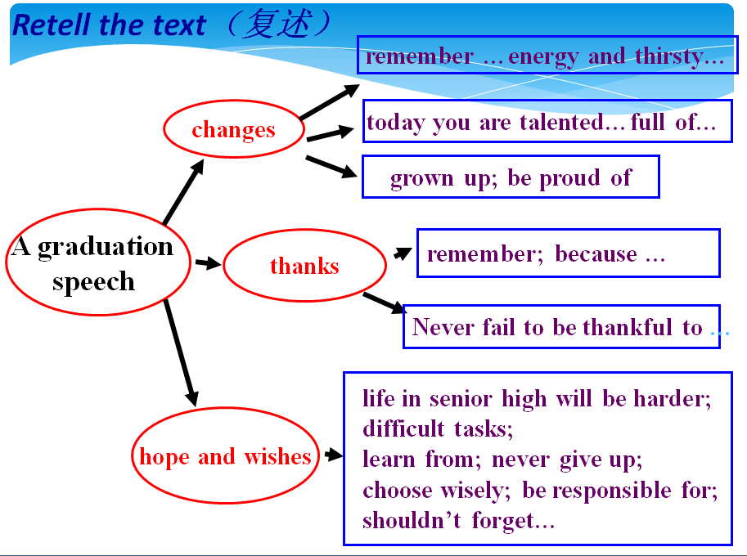

**探究二、**知识链接。

1. You were all so full of energy and thirsty for knowledge.

你们所有人都充满了活力并渴求知识。

be thirsty for 渴望；渴求

【小小翻译官】

我现在特别想喝橙汁。

I_____ _____ _____ orange juice right now.

他渴望取得更大的进步。

He_____ _____ _____ _____ greater progress.

2．Although you've all worked very hard over the last three years，none of you did it alone.

在过去的三年里，尽管你们学习都很刻苦，但你们都不是单枪匹马作战。

none可指人也可指物，作主语时，如果和of连用指不可数名词时，谓语动词要用单数形式；指可数名词时，谓语动词用单、复数均可。

none 可用来回答 How many / much…? 的特殊疑问句

【小小翻译官】

这些电影没有一部是精彩的。

None of these movies _____ wonderful.

这笔钱没有一分是我的。

None of the money_____ mine.

—教室里有多少个学生？

—一个也没有。

—How many students are there in the classroom?

—_____．

3．Good luck and hope to see you again sometime soon！

祝你们好运！希望早日与你们再见！

【辨析】sometime，sometimes, some times, some time

sometimes (有时) 频率副词，用于一般现在时；

sometime (在将来某时) 不确定的某个时间，用于将来时；

some times (数次) time 表示次数，有几次；

some time (一些时间) time 表示时间，一段时间。

【小小翻译官】

才艺表演将于下周某个时间演出。

The talent show will be put on _____ next week.

火车到达之前，我们还有一点时间闲逛一下。

We have _____ _____ to hang out before the train arrives.

有时候我喜欢一个人待着。

I like to be on my own _____.

我的爸爸去过几次纽约。

My father has been to New York _____ _____.

4．It is always hard to separate from those whom you have spent so much time with for the past three years.

与那些在过去的三年里和你并肩走过这么多时光的人分离总是很难的。

分离；隔开 _____

把A和B分开 _____

【小小翻译官】

理论不应该脱离实践。

Theory should not _____ _____ _____ practice.

请把白衬衫与有色衬衫分开。

Please _____ the white shirts _____ the colored ones.

**【课时小结】**

重点单词

1. gentleman *n.* 先生；绅士
2. graduation *n.* 毕业

3. ceremony *n.* 典礼；仪式

4. congratulate *v.* 祝贺

5. thirsty *adj.* 渴望的;口渴的

6. thankful *adj.* 感谢；感激

7. lastly  *adv.* 最后

8. task  *n.* 任务；工作

9. ahead *adv.* 向前面；在前面

10. responsible  *adj.* 有责任心的

11. separate *adj.*单独的；分离的 *v.* 分开；分离

12. wing *n.* 翅膀；翼

重点词组

1. attend the graduation ceremony 出席毕业庆典

2. separate from 分离；隔开

3. full of energy 充满活力

4. thirsty of knowledge 渴求知识

5. hope for the future 对未来的希望

6. never fail to be thankful to sb. 一定要向某人表达感激

7. give wings to fly 给某人飞翔的翅膀

8. set out on your new journey 开始你的新旅程

9. be responsible for your decisions and actions 对自己的决定和行为负责

10. go your separate ways 走自己的路

重点句式

1. First of all, I’d like to congratulate all the students who are here today.

首先，我要向今天在场的所有学生表示祝贺。

2. I hope you’ll remember the important people in your lives who helped and supported you.

我希望你们记住那些在你们的生活中帮助你们、支持你们的重要的人。

3. The key is to learn from your mistakes and never give up.

关键是要从错误中学习并永不放弃。

4. Along with difficulties, there will also be many exciting things waiting for you.

伴随着困难，一路上也会有许多令人兴奋的事在等着你。

5. As you set out on your new journey, you shouldn’t forget where you came from.

当你出发踏上你新的旅程时，不要忘了你来自哪里。

**【达标检测】**

**一、根据句意及汉语提示填写单词。**

1. I ________ (祝贺) him on his good exam results yesterday.

2. Our first ________ (任务) is to collect some information.

3. They're very happy to have ________ (单独的) rooms now.

4. I like the insect which has two beautiful ________ (翅膀).

5. I am ________ (口渴的). Could you give me some water?

**二、用方框中所给单词或短语的适当形式填空。**

be full of，give up，last，make mistake，be proud of

6. ________, could I ask all of you to keep this information secret?

7. —Mom，I was the first to reach the top of the mountain.

—Good job，Jack！I ________ you.

8. David Beckham decided to ______ playing football match forever because he is not energetic enough.

9. People who are afraid of ________________ will never succeed.

10. The subject may ________________ interests to you, but I don't like it at all.

**三、单项选择。**

11. —Mom，I got the first place in the exam.

—________.

A. Have a good rest B. Thank you

C. Good luck D. Congratulations

12. Bob's mom is happy to see that he is full of energy and ________ knowledge.

A. is famous for B. is thirsty for C. is familiar with

13. I'd like to congratulate you ________ your good grades.

A. to B. with C. about D. on

14. I'm going to be a manager ________.

A. in future B. in the future

C. at future D. at the future

15. You should ________ your actions.

A. be thirsty for B. be responsible for

C. separate from D. catch up

**四、根据汉语意思完成句子，每空一词。**

16. 日本比我们这儿快一个小时。

Japan is one hour ________ ________ us.

17. 这些旅行者休息三天后又上路了。

After a three- day rest，the travelers ________ ________ again.

18. 首先，你必须完成你的作业。

________ ________ ________, you must finish your homework.

19. 绝不能强行使任何一个孩子与母亲分开。

No child should ever be ________ ________ his mother by force.

20. 作为父母，我们必须对你的决定负责。

As parents, we must ________ _____ _____ your decisions.

**五、短文填词。**

用方框中所给单词的适当形式填空，使短文意思完整、通顺。

|  |
| --- |
| refuse，possible，look，more，article，hear，serious，arrive，as，joke |

Before graduation，many classmates were busy 21 for jobs. So was I. It was very difficult to find a job in the big city. I had been 22 for many times until I found a want ad for an editor. “If you could find 23 than 10 wrong words in the newspaper，you can work 24 an editor,” the ad said. I loved literature (文学) and had written several little 25 for the newspaper. So I decided to have a try. It was the final date when I saw the newspaper. I told one of my roommates the news happily. After he 26 the news，he smiled and said “Today is April Fool's Day. It may just be an April Fool's 27 . A fool may take it 28 .” I was very disappointed after hearing that，but I still wanted to have a try. It took me the whole morning to find 12 wrong words in the newspaper. I 29 at the editorial department in the afternoon and got the job immediately.

Later I knew I was the only applicant(申请者). I got a lesson from the experience: Something others said was 30 may be not impossible. As long as you believe it，you may make impossible possible.

21._____ 22._____　23.______ 24.______　25._____

26._____ 27._____ 28._____ 　29.______ 30._____

**【自我评价】**

1. 本课我学会了什么？

__________________________________________

2. 通过本课的学习，我还有哪些疑问？

__________________________________________

**参考答案：**

【课前预习】

1. gentleman
2. ceremony
3. congratulate
4. thirsty
5. lastly
6. task
7. ahead
8. responsible
9. wing
10. attend the graduation ceremony
11. separate from
12. full of energy
13. thirsty for knowledge
14. hope for the future
15. never fail to be thankful to sb.
16. give sb. wings to fly
17. set out on your new journey
18. be responsible for your decisions and actions
19. go your separate ways
20. be thankful to the people around you
21. be responsible for your decisions and actions
22. set out on your new journey

探究一

① It is a speech.

② The principal of the school is probably the person who wrote it.

③ It is for the graduating students of the school.

Ladies and gentlemen,

Thank you for coming to attend the graduation speech today. First of all, I’d like to congratulate you. In Grade 7 all of you were all so full of energy and thirsty for knowledge. But today I see a room full of talented young adults who are full of hope for the future. I think you’ve all grown up so much and I’m so proud of you.

Next, there are many important people around you, such as your parents, your teachers, your classmates and your friends, you should thank the people around you and never fail to thank the people around you.

Lastly, the end of junior high school is the beginning of a new life. The life in senior high school will be harder and difficult tasks. So I will give you some advice. First, you should open are chances to learn new things. Next you should choose wisely and be responsible for your decisions and actions. Finally as you set out on your new journey, you shouldn’t forget where you are from.

探究二

1. am thirsty for; is thirsty for making
2. is/are; is; None
3. sometime; some time; sometimes; some times
4. separate from; separate A from B; be separated from; separate; from

【达标检测】

一、 1. congratulated　2. task　3. separate　4. wings　5. thirsty

二、 6. Lastly　 7. am proud of　 8. give up

9. making mistakes　10. be full of

三、 11-15　DBDBB

四、 16. ahead of　 17. set out　 18. First of all

19. separated from 20. be responsible for

五、21. looking　22. refused　 23. more　24. as

25. articles　26. heard 27. joke　28. seriously

29. arrived　30. impossible